(Approx. 1591 words)

Meeting Review
Big changes coming to media, entertainment, newspapers
Authors: Michael Shalkey, Computer Tutor and Troubleshooter and John Weigle, Editor, Channel Islands PCUG, CA
September 2019 issue, The TOE
www.cipcug.org
jweigle (at) vcnet.com

Things are changing quickly in the world of media, entertainment, and newspapers, Michael Shalkey said at our last meeting.

Lawyers, big corporations, money and the Internet are behind the changes, he said.

TV networks used to broadcast over the air using signals of a certain frequency. The broadcasters had to pay a fee for the frequencies, and they charged businesses for advertisements. Anyone could put up an antenna and get the broadcasts as free TV.

When cell phones came in, fewer people were getting over-the-air signals. The government took some of the frequencies back and is selling them to cell phone carriers. On June 12, 2009, they went from analog to digital, a different type of wave form.

You may not have noticed then because most of us are getting our TV from cable or satellite providers. Those providers pay TV channels to be included in their package.
You have seen disputes for years about these fees.

Recently CBS and Direct TV fought over the amount that CBS would be paid to be on the Direct TV service. For a few weeks you couldn’t watch CBS, but they resolved it (for now) and you can now watch CBS like normal, but I think the death of TV as we know it is coming soon. CBS did this because, although it came out with CBS All Access in 2014 it is now ready to really push it with exclusive streaming-only content.

That time when you couldn’t watch CBS was the genesis for this presentation. Here is how to watch CBS on your TV using an app for your streaming box.
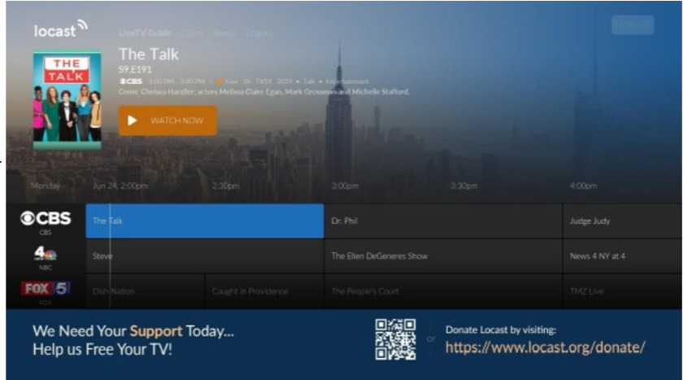

All of us hate the amount of money we spend each month for TV. Many have added boxes to watch content from the internet. Some have already become cord-cutters and get their TV only that way.

Definition first. Sometimes the word streaming means following the TV schedule, just over the internet, sometimes it is used for on demand, which means I want to watch something, and I want it now.

Live TV is now viewable using the LoCast app. It is very, very interesting. It’s a non-profit that can legally pick up signals for free. It can put its own ads over the other ads. Because it’s a local service, the programs available differ from area to area.

Some of you may remember a similar service a few years ago called Aereo that had antennas in New York that received over-the-air signals and allowed subscribers to view those signals. Lawsuits went all the way to the Supreme Court, which ruled against them partly because they were reselling the content without permission of the copyright owners. The hope for LoCast is that as a nonprofit, it is not selling anything. There will be lawsuits, but one of the supporters of LoCast is ATT, which has donated generously to LoCast.

You can get LoCast with most of the boxes like Roku, FireTV and similar boxes — and even a smart TV. The on-demand services like Netflix, Hulu, Amazon Prime Video, and HBO Go are also available on those boxes but they charge a monthly fee. These are becoming so popular that if you have never tried them, you probably will soon.

If you want to start a conversation waiting in line at a store or bank, say, “I just got Netflix. What should I watch? You can shut up for 10 minutes.”

Toby Scott said to expect a fight over something that’s recommended.

Many shows are exclusive, meaning they’re available only on one of the services.
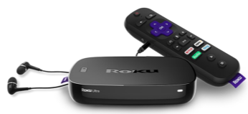

One of the people in the audience wants to watch TV at a louder volume than others in the room. He wants to have earphones. He can pair a device with his Bluetooth headphones to the Amazon Fire Cube through settings or through the newer Roku boxes that have a headphone jack in the remote control. (See photo above)

Shalkey was showing two devices: Amazon Fire Cube and Roku version 3. The headphone jack in the Roku remote shuts the volume off on the TV and puts it in the headphones or earbuds you have plugged in.

The August 2018 TOE has the program on the Amazon Fire Cube including the voice activation and channel changing.
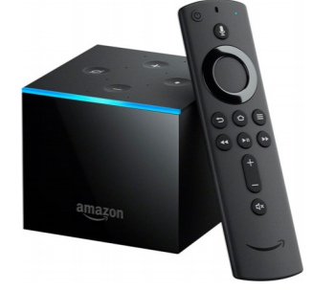
One Fire TV Cube feature — as you can see — is the slideshow feature (above). As you know, I like wine. My wife and I went to a wine event in Paso Robles. We can take as many pictures as we want on our phones and upload them to Amazon Photo. It’s free. I then put those photos in their own folder. Now I can set the FireTV Cube to show the pictures in that folder and talk about them when friends come over.

For streaming services, the big three are Hulu, Netflix and Roku. The up-and-comers are HBO-Go, YouTubeTV, CBS All Access, and the new Disney Plus (launching in November).

With Netflix, Hulu and Amazon you can have profiles so you will be offered films that match your previous choices, he said. Some of the shows on these channels could not be sold to the big networks, he added.

A lot of the old favorite shows are being pulled back by the networks that broadcast them originally.

Q. Do you see the future as cord cutting?
Michael Shalkey: Yes. I think in the future no one will have home phones, newspapers and cable TV. The satellite and cable people are doing this to themselves. For people who are cutting the cord because of the cost it’s going to be hard to decide what they want to keep and to be sure that cutting the other things are not more expensive than the bundle.

Q: If you get rid of the phone and TV what are you going to pay for internet?
Michael Shalkey: It depends on where you are and what you need. Depending on where you live, you might not save much by cutting everything. When you are calculating, please do the math right. If you are already an Amazon Prime member, there is no cost for Amazon Prime Video. If you currently have Internet in your house (and who doesn’t)? you can’t really count that as an added cost in the cord-cutting scenario unless you are seriously thinking about getting rid of the internet at home.

Q: I have a home with two TVs for two families and Wi-Fi for cell phones.
What speed do I need to run effectively?
Michael Shalkey: It depends. I would not think of moving into a new home now and having less than 15 megabits per second. It really depends on your users. Music is already streaming. How many of you have bought a music CD in the last year? How many of you have an AM radio (few said yes). Big producers have changed the music world. The TV world is not far behind and many changes have been made in music.

Q: I was watching a Prime movie, and there were commercials, which I haven’t noticed before.
Michael Shalkey: It’s their platform. I haven’t seen them, but they can advertise their own shows particularly before the movie (kind of like a movie trailer in a theater).

Q: Can we have more than one of such devices and listen to different things in different rooms?
Michael Shalkey: Yes. I can watch a movie on Netflix in the bedroom while my wife watches something else in the living room on her box. I don’t think smart TVs are that smart. The manufacturers don’t update the apps.

Q: How many options do you have and what do you pay for them?
Michael Shalkey: You pay for the Roku box but you don’t pay to use it. I pay for Netflix, and I pay for Hulu and I’m a prime member of Amazon, but I don’t count it as a monthly expense because I buy so much. I’d be saving a lot of money if I could get my wife to drop Direct TV, but she does like her Hallmark Channel.

Q: What about live sports and news reports?
Michael Shalkey: It depends on what you want and what the channel you want is doing. LoCast is live TV, but that is only the traditional over-the-air networks. It does not include ESPN, CNN or MSNBC.

Q: Do you find much overlap in the channels you get?
Michael Shalkey: Yes and no. Yes, different boxes get the same “channels” like Netflix, but I don’t pay more per month for each device, so that’s no problem. I don’t see much overlap.

Comment: The Amazon Echo can also play radio stations, and if you have more than one they can be used as an intercom.
Michael Shalkey: You can also use them to make phone calls.

